USER MANUAL

Home Page (Task Calendar):

Hover the mouse over a day on the calendar, it will show the number of tasks due that day and also the tasks that are due. Clicking on the day will open a small view underneath the calendar where the description and other related information of the task is available.

* The days on which no tasks are due appear green.
* The days on which 2 tasks are due appear yellow.
* The days on which more than 3 tasks are due appear red.

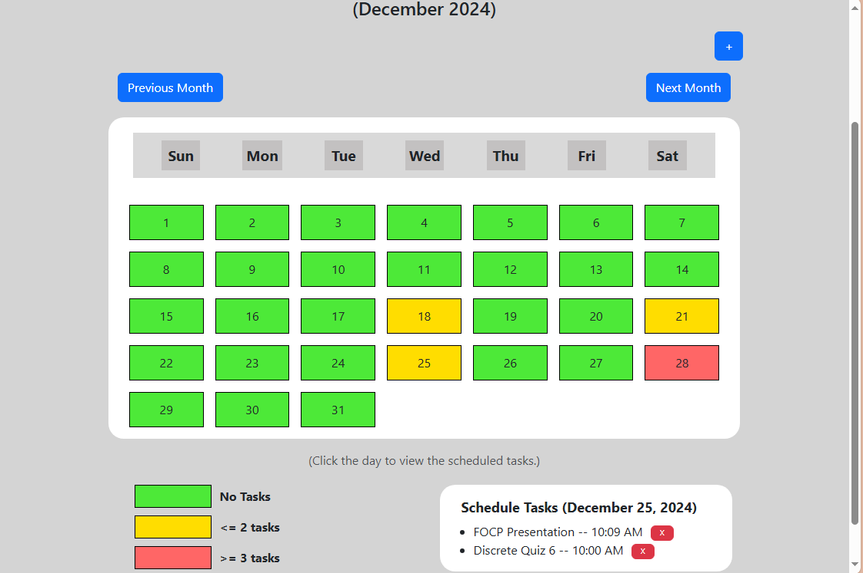

Aggregate Calculator:

Navigate to your desired subject, this will redirect you to a new webpage where different tests and quizzes are available with input boxes, here enter your marks in each examination. Then click on “Calculate Aggregate” to find the aggregate in that subject according to the already pre-set weightages. Your aggregate will be shown at the bottom of the webpage.

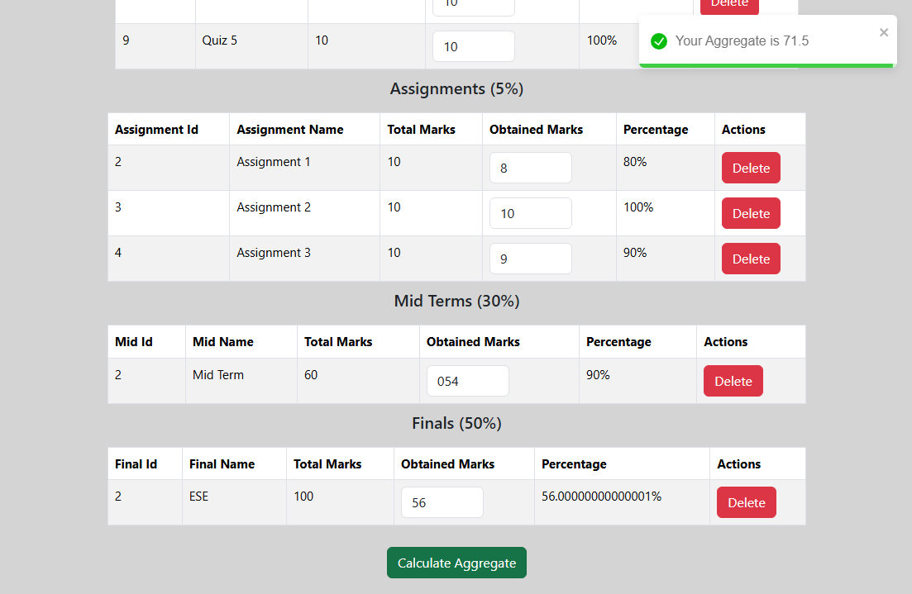

Quiz Bank:

Navigate to your desired subject, the related questions and answers will show up below the subject names. Read each question and think of its answer. Now click on the “Show Answer” button. This will reveal the answer so that you can confirm your answers.

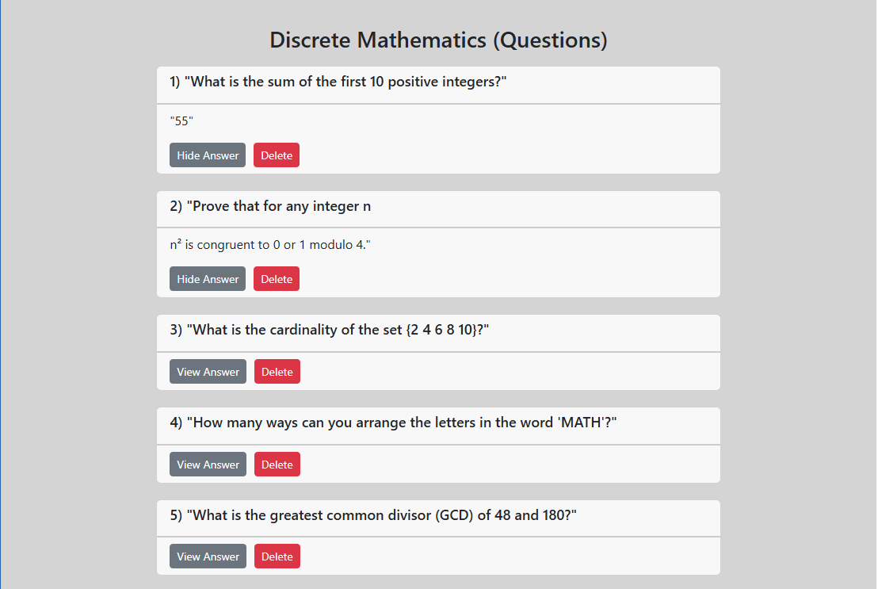

Group Former:

Navigate to the Group Former page and go to a certain ONGOING group forming section. This will redirect you to the preference page. Here you will see a list of all the students in your class. Now find those among the list whom you want to be in a group with. Then mark the check box on those candidates. You can only select “n-1” preferences in a session where the group size is n. After selecting your preferences, click on the “Submit Preference” button to confirm your choices. After the pre-defined time has been exhausted, the formed group will be available under the COMPLETED groups. You can go into there and look at all the groups that have been made. If you did not give any preferences, you will be randomly assigned a group.

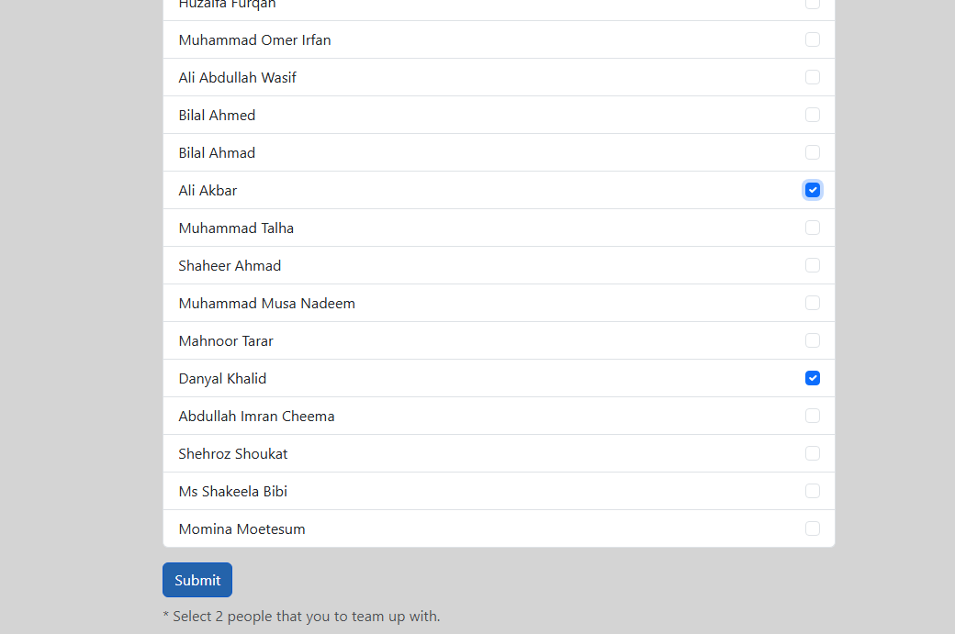

Profile:

Navigate to the profile page, here your email address and password are shown. You can also change your current password by clicking on “Change Password”. This will create a pop up window, here you will be prompted to “Enter the new password” and “Enter the new password again”. After this your password will be changed.

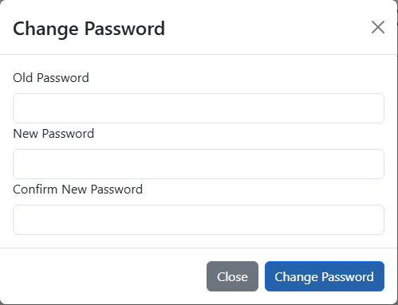

ADMIN MANUAL

Home Page (Task Calendar):

The admin can add new events to the calendar by clicking on the plus icon and adding the event name, event description and the deadline of the event. This adds the task directly to the database and is shown to all the users.

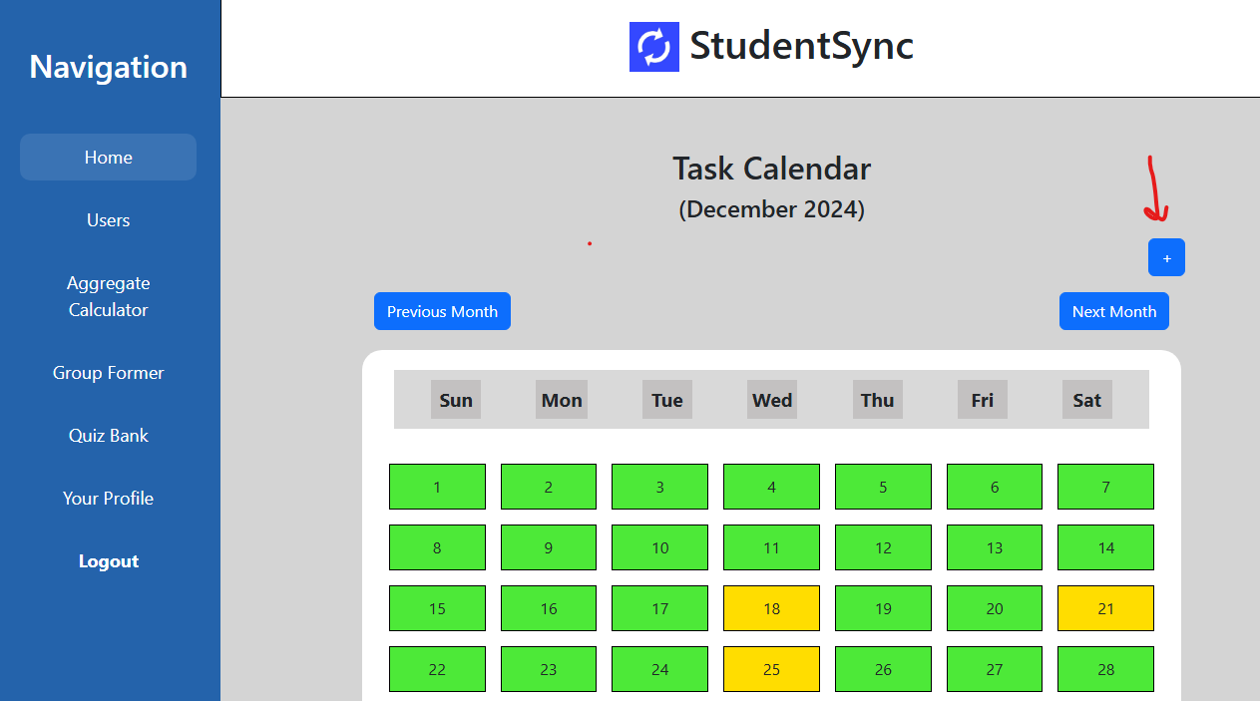

Aggregate Calculator:

You can create a new subject for which the user can find his aggregate. Click on the plus icon in the aggregate calculator page. This will open a pop-up window where you can add the name of a subject. Now open that subject’s window, now you can add a new quiz, or assignment by entering the weightages into the designated places. Now, click the “Submit” button to save these preferences. Now, the user can use these new weightages to calculate their aggregate in the subject.

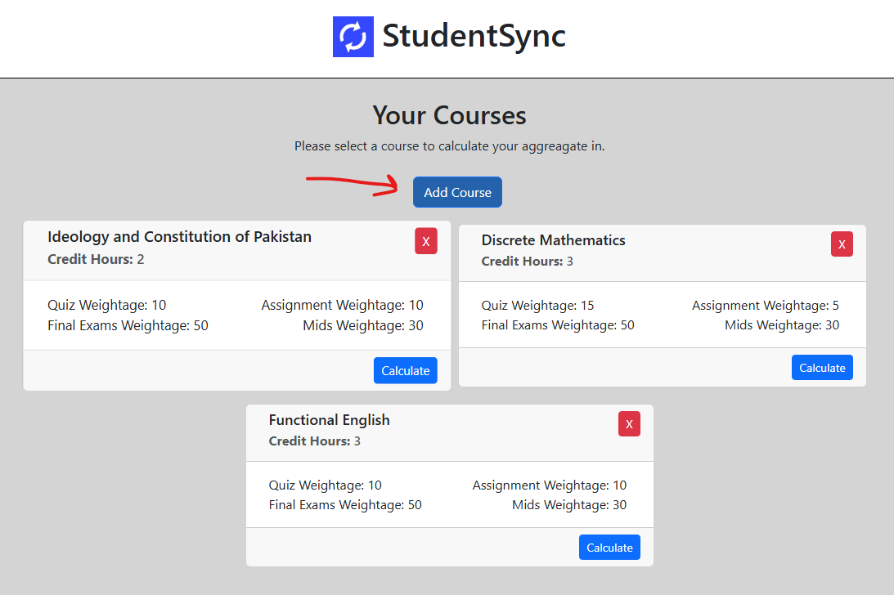

Quiz Bank:

You can add a new questions into the database for a certain subject, click the “Add new question” button, now enter the “Question” and the related “Answer”. This will append a new question into the database.

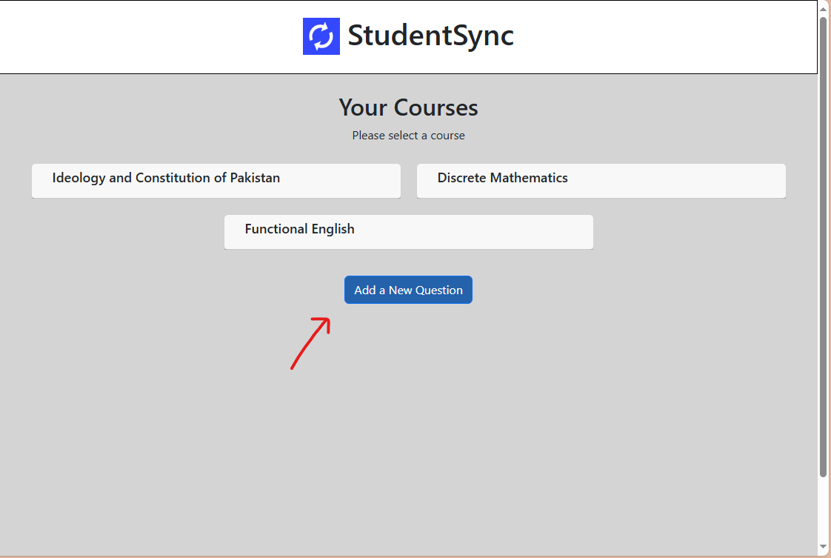

Group Former:

Open the Group former page, to start a group forming session, click on the “Create new session” button. Now input the purpose of the groups to be formed and the group size. After the time for the students to give preferences has elapsed, click on the “Form Groups” button. This will form all the groups.

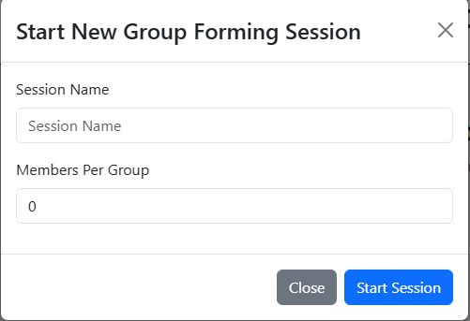

User Database:

This is an admin only page, accessible only to the admins. Here the admins can see all the users who can access to the website. They can promote a user to an admin, by clicking on the “Make Admin” button besides each user. They can also add more users into the system by making their accounts.

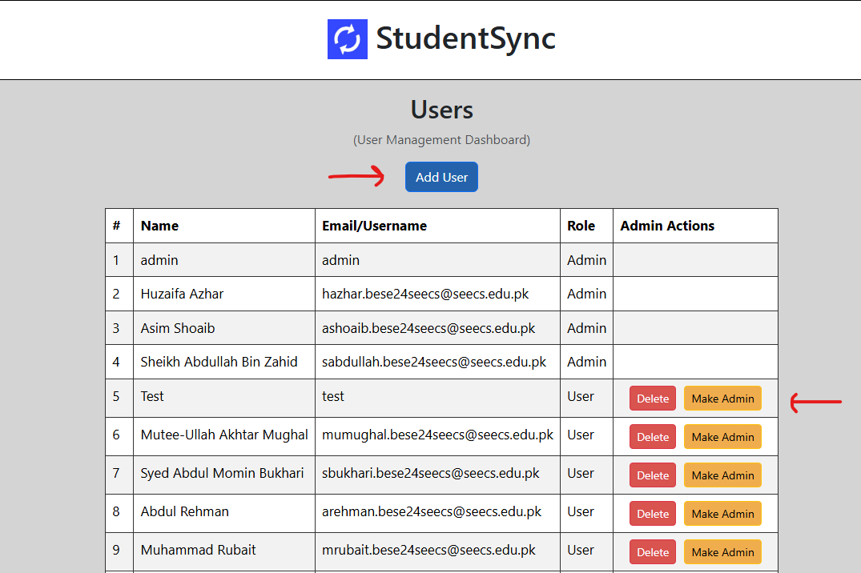

Profile:

The profile page is where you can change your password by specifying the old and new password in the pop up window.

